EXPERIMENT : BEST FIRST SEARCH ALGORITHM
Aim:
To implement the Best First Search algorithm using Prolog for finding a path from a start node to a goal node.

Objectives:
- To understand the concept of Best First Search in Artificial Intelligence.
- To implement heuristic-based searching using Prolog.
- To select the node with the lowest heuristic value from the open list.
- To find an optimal path from the start state to the goal state.
- To demonstrate the working of informed search algorithms.

Algorithm: Best First Search
Step 1: Start the program.
Step 2: Define the graph with nodes and their connections.
Step 3: Define heuristic values for each node.
Step 4: Initialize the open list with the starting node.
Step 5: Select the node having the lowest heuristic value from the open list.
Step 6: Check whether the selected node is the goal node.
- If yes, display the path.
- If no, continue searching.
Step 7: Expand the selected node and add its child nodes to the open list.
Step 8: Sort the open list according to heuristic values.
Step 9: Repeat steps 5–8 until the goal node is reached.
Step 10: Stop the program.

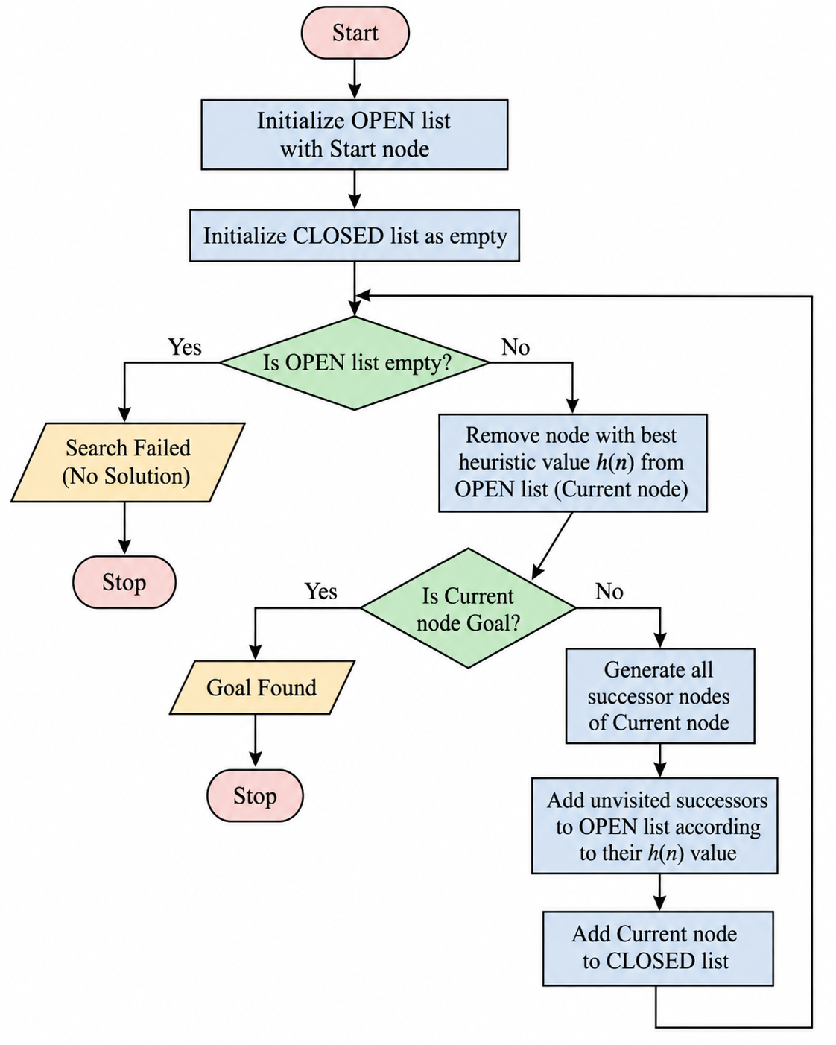

Source Code:
% Best First Search Algorithm in Prolog

% Graph representation
edge(a, b).
edge(a, c).
edge(b, d).
edge(b, e).
edge(c, f).
edge(c, g).
edge(d, h).
edge(e, h).
edge(f, h).
edge(g, h).

% Heuristic values
heuristic(a, 8).
heuristic(b, 6).
heuristic(c, 5).
heuristic(d, 3).
heuristic(e, 4).
heuristic(f, 2).
heuristic(g, 1).
heuristic(h, 0).

% Best First Search
best_first(Start, Goal, Path) :-
search([[Start]], Goal, RevPath),
reverse(RevPath, Path).

% Goal test
search([[Goal|Rest]|_], Goal, [Goal|Rest]).

% Continue searching
search([[Node|Path]|Paths], Goal, Solution) :-
findall([Next,Node|Path],
(edge(Node,Next), \+ member(Next,Path)),
NewPaths),
append(Paths, NewPaths, AllPaths),
sort_paths(AllPaths, SortedPaths),
search(SortedPaths, Goal, Solution).

% Sorting paths based on heuristic value
sort_paths(Paths, Sorted) :-
map_list_to_pairs(path_value, Paths, Pairs),
keysort(Pairs, SortedPairs),
pairs_values(SortedPairs, Sorted).

% Calculate path heuristic value
path_value([Node|_], Value) :-
heuristic(Node, Value).

OUTPUT
